Data Science Guided Capstone

**The Big Mountain Resort Pricing Strategy**

Price Modeling

horizontal line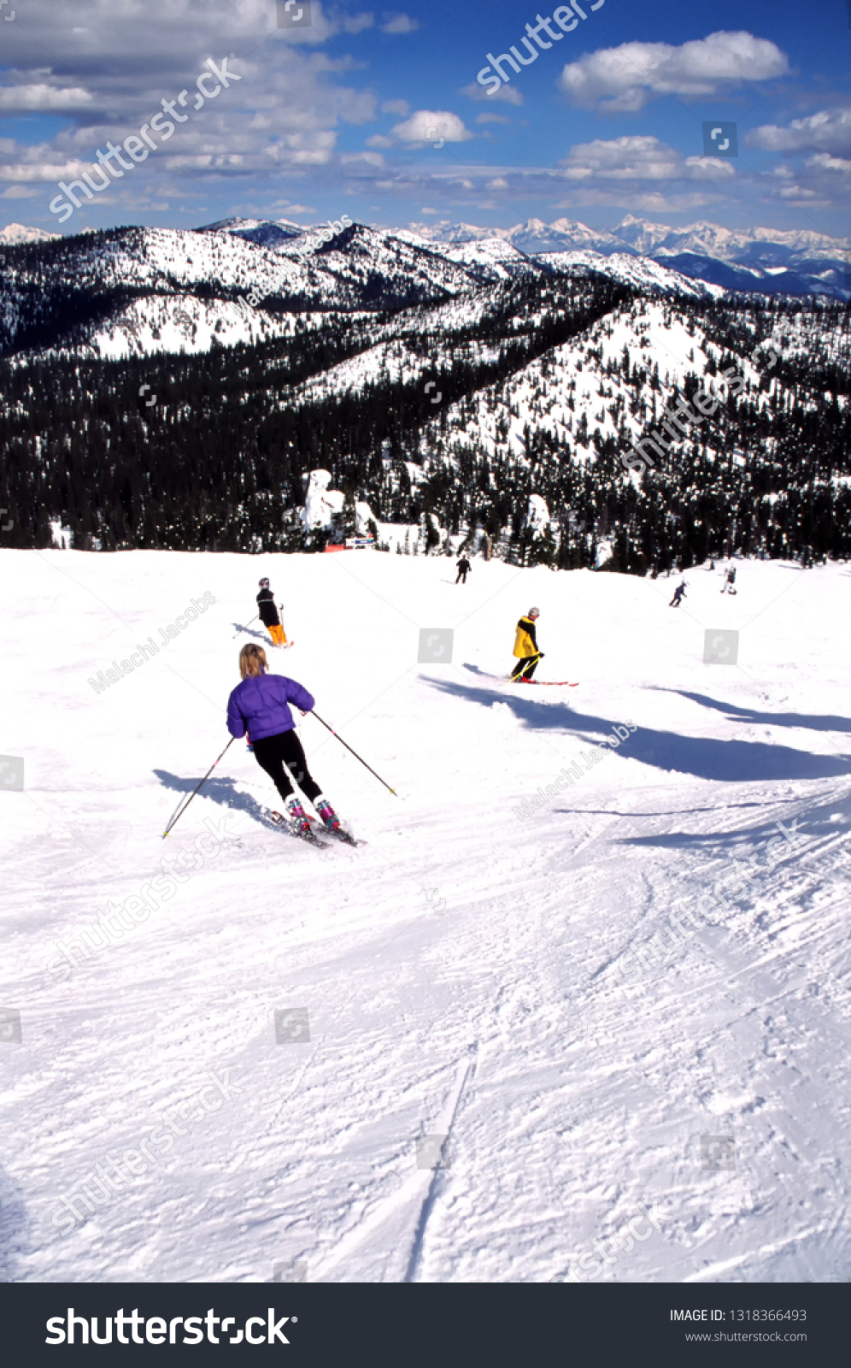

# **Introduction**

This project introduces a pricing model for the Big Mountain Ski resort in Montana. The Big Mountain Resort pricing model has been based on the average price of its skiing market segment. The resort premium price is slightly above the average price. The resort operational cost is increased by $1,540,000 after installing an additional chair lift. Basing the price on just the market average does not differentiate important facilities from other competitors' facilities. Both machine learning models, Linear Regression, and Random Forest showed that the resort does not capitalize on its facilities as it should. The modeling suggested that the resort is likely charging $14.2 less than it should be.

# **Used Data**

## **1 - The Main Data**

The original data contains 330 rows (entries or observations) and 27 columns. Each row represents an entry of a particular skiing resort, and the columns represent features of this resort. These features identify the resort, such as the name and region, lifting and mobilization facilities, and other information such as elevations, runs, and average snowmaking. The ticket prices are listed for weekdays and weekends.

## **2 - External Data from Wikipedia**

Population and area data for the US states is obtained from [[wikipedia](https://simple.wikipedia.org/wiki/List_of_U.S._states)](<https://simple.wikipedia.org/wiki/List_of_U.S._states>). Combining the two data sets led to deriving Resort density information such as resorts per capita and resorts per square mile.

# **The Used Method**

First is data wrangling to clean the data and handle the missing values. Then, exploratory data analysis (EDA) is conducted to understand the potentially important business features and identify its relationship. The EDA step helps to select features that matter for the business and help predict the price. Then, the preprocessing step of refining the features followed by the modeling. The learning regression and the Random Forest models were used to predict the prices.

# **Discussing the Analysis Outcomes**

## **The pricing models**

Both models are used to predict the prices considering the Adult weekend prices, which has less missing values. The Random Forest model is selected because of better performance.

## **The price prediction**

The big mountain resort is currently charging $81 for the adult weekend ticket price. The model suggested the price to be ($95.20). Even with the uncertainty (the expected mean absolute error of $10.39 of the mode)l, there is room for increasing the price. The model shows that the big mountain resort is undercharging for the provided skiing facilities compared to others in the market, assuming other resorts adopt an appropriate pricing strategy.

## **Unleveraged Facilities**

The big mountain resort is among the top resorts with high values of the important skiing facilities highlighted by both models such as vertical drop, Snow Making, total chairs, fastQuads, Runs, Longest Run, trams, and Skiable Terrain. The figures below show the distribution of the values of the prices and other important business features.

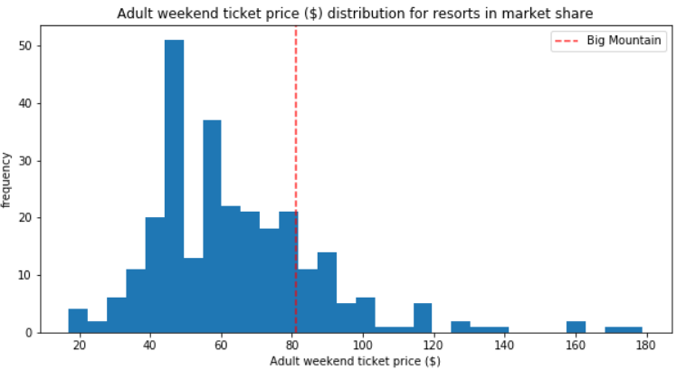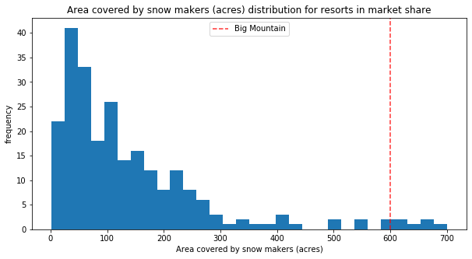

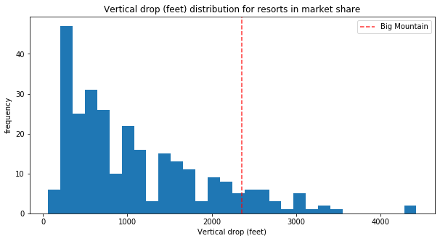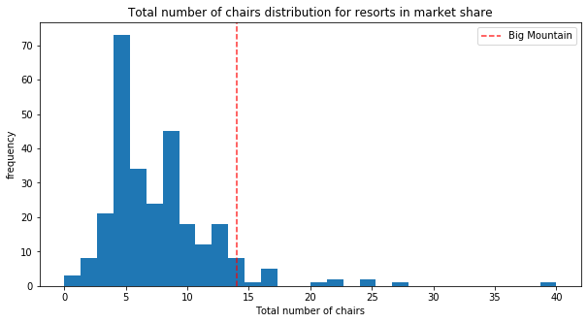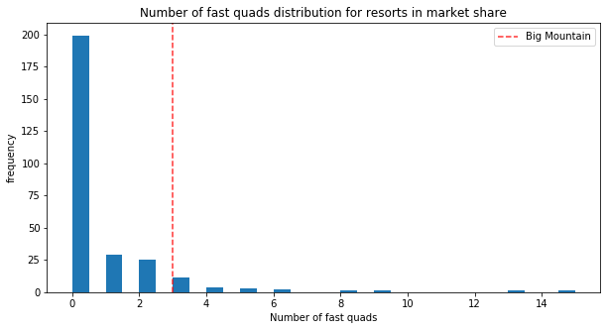

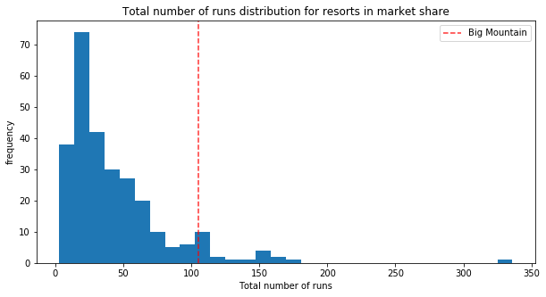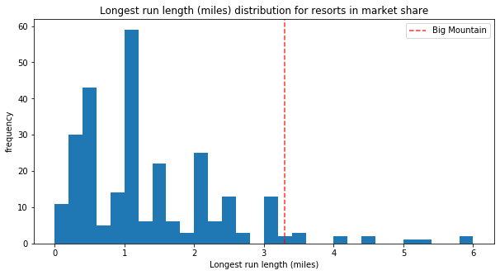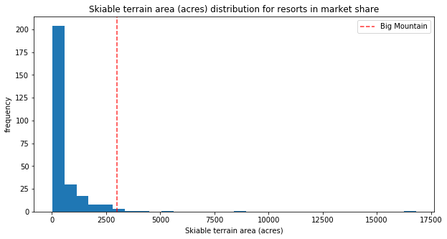

The figures above demonstrate that the big mountain resort among the top resorts that have high values of important business features.

## **Business Scenarios**

The model is used to assess the potential scenarios for either cutting costs or increasing revenue (from ticket prices). The expected number of visitors over the season is 350,000, and, on average, visitors ski for five days.

**Scenario 1**: Close up to 10 of the least used runs. The model shows that closing one run makes no difference. Closing up to 5 runs reduces $0.5 of the ticket price, which reduces the season revenue by ($875,000.00). Increasing the closures down to 6 or more leads to a large drop in price and revenue.

### **Scenario 2**: add a run, increase the vertical drop by 150 feet, and install an additional chair lift. This scenario increases support for ticket price by $1.99 and increases revenue by $3,474,638 for the season.

**Scenario 3**: add 2 acres of snowmaking to scenario 2. The model shows that such a small increase in the snowmaking area makes no difference!

**Scenario 4**: increase the longest run by 0.2 miles and guaranteeing its snow coverage by adding 4 acres of snowmaking capability. The model shows that this scenario introduces No difference whatsoever in price and revenue.

The big mountain resort may consider scenario 1 of closing some runs by calculating the potential loss in revenue against the amount of money saved by reducing operational costs. Also, scenario 2 can be evaluated by comparing the added facilities' installation and operational cost against the potential gain in revenue.

# **Future Work**

Although Big Mountain was already fairly high on some of the league charts of facilities offered, the model showed a clear undercharging of its ticket price. The modeling relied on the available data and based on the implicit assumption that all other resorts are accurately setting prices based on how much people value certain facilities. More data about the supply and demand and the operational cost could lead to better modeling and more informed business decisions. Business analysts can use this model to inform future business decisions regarding any further investment or reduction in operational costs. The predict_increase() function can be simply used to explore various scenarios.